**Spring Boot Course – Chad Darby**

Spring Boot runs on top of Spring Framework, it uses Spring framework underneath along with other Spring Projects Like Spring Web, Spring MVC, Spring Rest API like these there are many spring projects which we can use to create a Spring Boot App

* Minimizes manual configurations
* Handles the dependencies (JARs) using MAVEN or GRADLE
* Comes with Embedded Server (TOMCAT, JETTY etc.) can be run standalone because of this.

MYAPP.JAR

TOMCAT SERVER

CODE

Run Spring Boot Application in CMD

***java -jar myapp.jar***

How to create Starter Spring Boot Application – <https://start.spring.io>

* Here you can select the java version, build tool (Gradle or Maven)
* Add dependencies
* Add the project and package names

Creating Simple Rest Controller in Spring Boot (Hello world App)

@RestController  
public class MyController {  
 @RequestMapping("helloworld")  
 public String helloWorld() {  
 return "Hello, World!";  
 }  
}

There are many spring projects which we can use in our application some of the examples being Spring Web, Spring Data JPA, Spring Security, Spring MVC etc.

We can learn more about spring project here <https://spring.io/projects>

**What is Maven?**

Maven is a project management tool, it manages dependencies.

Dependencies of our application requires several JAR files which need to be downloaded from the internet Central MAVEN repository, this is handled by Maven project management tool, Gradle is also same as Maven.

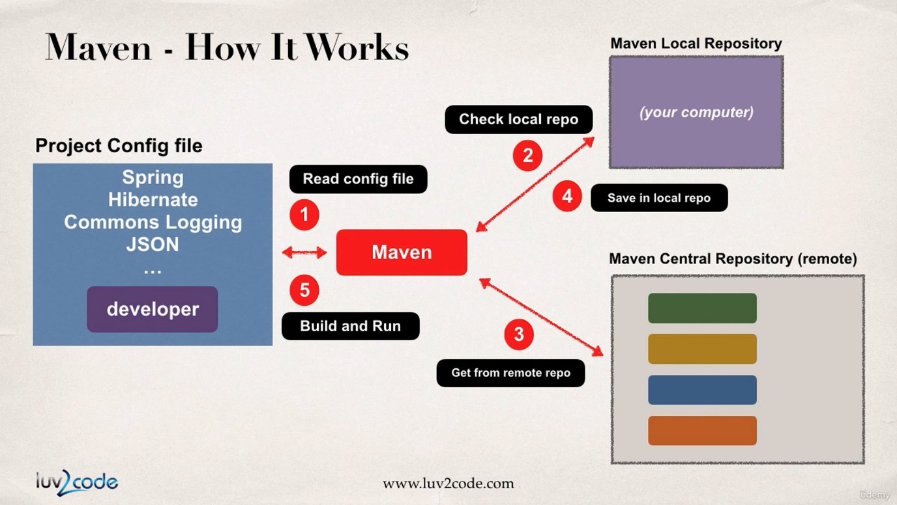

Working of MAVEN, it will read config file first and checks local maven repo, and If required JARs are not found in local it will get them from Remote Maven central Repository.

Maven will build and handle your app

Maven will add class paths

Based on Config file Maven will add JAR files

**MAVEN Concepts**

**groupId** – name of company (com.google)

**artifactId** – name of the project (maps)

**version** - version of the project (1.2.2) (com.google.maps – 1.2.2)

**Adding Dependencies in pom.xml file**

<dependencies>

<dependency>

<groupId></groupId>

<artifactId></artifactId>

<version></version>

</dependency>

…

</dependencies>

You will get this in MVN Central website, and reading this config file Maven will build your app by importing required JARs

**Spring Boot project structure**

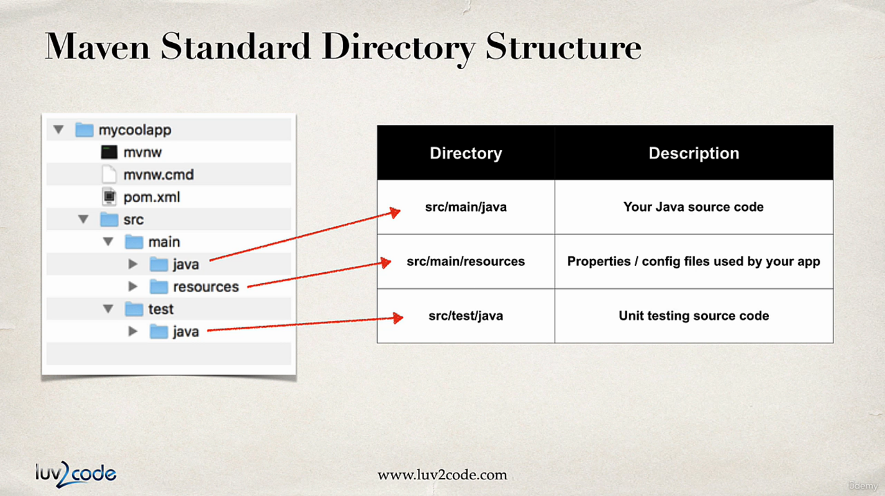

**mvnw.cmd(win) and mvnw (linux/mac)** are maven wrapper files which are used to automatically download the correct version of maven and run the maven for the application.

**pom.xml** is used to add dependencies and plugins required for the project application.

**application.properties** : we can add the properties for application in this file

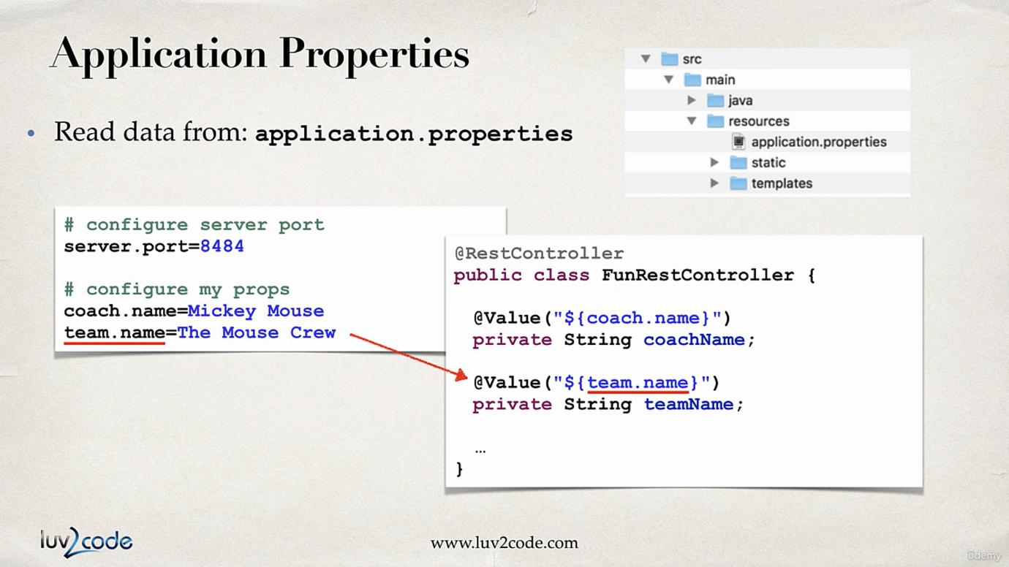

**Spring boot starters:** A dependency which is a collection of other dependencies which are bare minimum requirement to build application.

For e.g. **spring-boot-starter-web**, this contains -> Spring Web, Spring Web MVC, Hibernate-validator, json, Tomcat. (Add Spring Web in Spring initializer)

<https://www.javatpoint.com/spring-boot-starters>

**Spring boot starter parent:** These are maven defaults, this contains default compiler version, UTF-8 source encoding, others…

In <properties> it contains java.version which we are using for the project

<plugins> is used to configure application to run in command line using a command *mvn spring-boot:run*

**Spring Boot Devtools:** By using this dependency we no need to restart the application after every change, whenever we save the changes to file the spring app automatically restarts.

Dependency - **spring-boot-devtools**

IntelliJ configuration of Devtools:

Settings>Build, Execution, Deployment>Compiler -> Build project automatically

Advanced settings > allow auto-make

**Spring Boot Actuator:**

Exposes endpoints to monitor and manage our application.

It is like a Devops functionality

Simply add Dependency to your pom file

Dependency - **spring-boot-starter-actuator**

Endpoints

* **actuator/health** – this gives the status of application – UP/DOWN, By default only this endpoint is exposed
* **actuator/info** – this gives information about our application and we need to configure this by default it will give empty. And to expose this endpoint we need to add this in application.properties file.

#Actuator config  
management.endpoints.web.exposure.include=health, info  
#using =* will expose all endpoints

#management.endpoints.web.exposure.exclude=info,mappings like this we can exclude endpoints from exposure  
management.info.env.enabled=true

# /info setup  
info.app.name=Hello world  
info.app.version=1.0.0  
info.author=shivaraj

* **actuator/auditevents** – audit events for application
* **actuator/beans** – gives all the beans used in application
* **actuator/mappings** – gives all the mappings used in application.
* **/actuator** – we will get all actuator endpoints.

[Full list of actuator endpoints](https://docs.spring.io/spring-boot/reference/actuator/endpoints.html#page-title)

Secure actuator endpoints using Spring security

Add spring-boot-starter-security and then username is user by default and in terminal we will get default password

We can set custom user by using

#spring security user config  
spring.security.user.name=shivu  
spring.security.user.password=shivu

**Running Spring boot application from command line**

We can run easily because there is embedded server inside our app

* Using **java -jar**1. First open cmd in working directory of application  
  2. Run **mvnw package** (or ./mvnw package) – this will create a jar in /target

3. Run **java -jar target/myapp.jar**

* Using **Spring Maven Plugin**1. First open cmd in working directory of application  
  2. Run **mvnw package** (or ./mvnw package) – this will create a jar in /target

3. Run **mvnw spring-boot:run** (or ./mvnw spring-boot:run)

**Custom Application Properties and Injecting them using @Value()**

We can define custom properties for application in application.properties file

And we can use them in any bean/class using @Value annotation

File: application.properties

#Define custom properties  
company.name=clarivate  
company.employee=shivaraj

File: MyController.java

@RestController  
public class MyController {  
 @Value("${company.name}")  
 private String companyName;  
 @Value("${company.employee}")  
 private String employeeName;  
 @RequestMapping("helloworld")  
 public String helloWorld() {  
 return "Hello, " + employeeName + " from " + companyName;  
 }  
}

**Spring application properties**

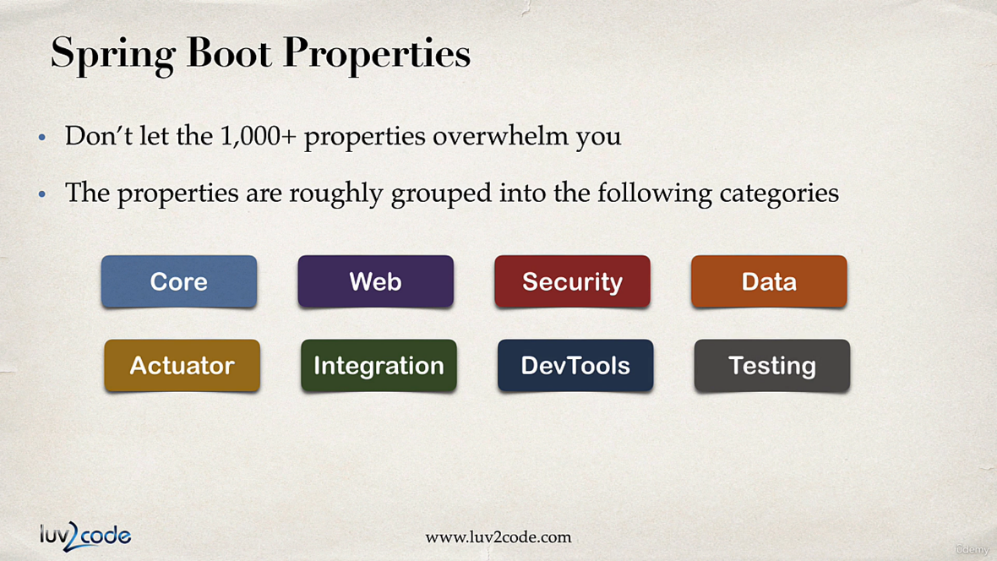

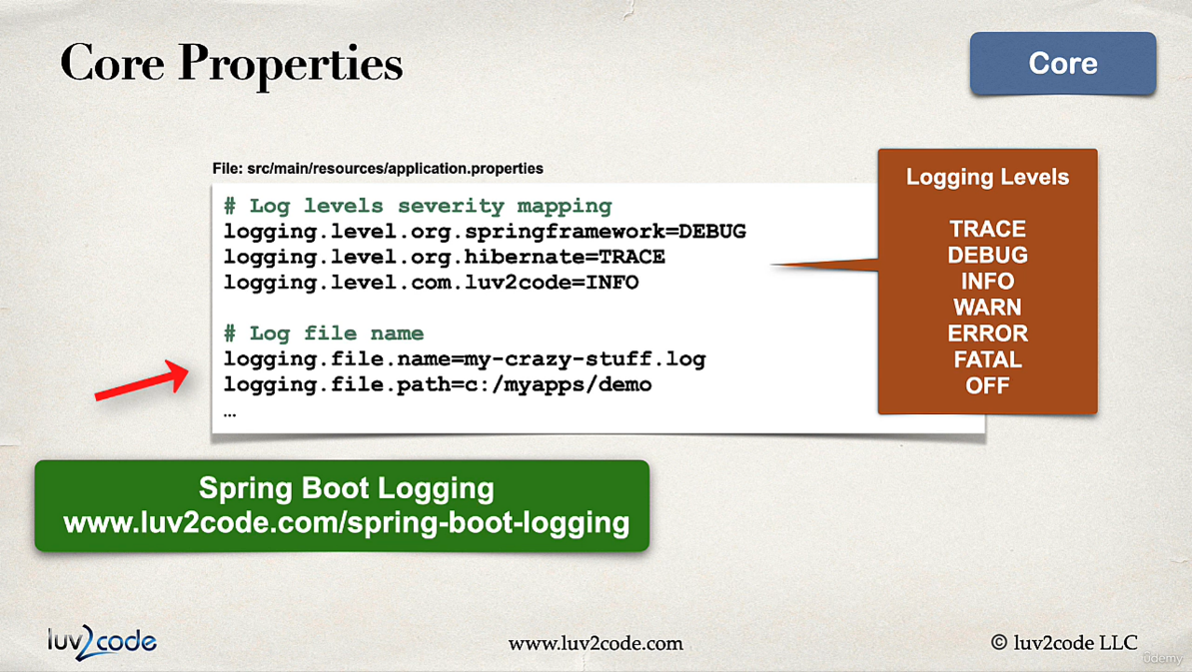

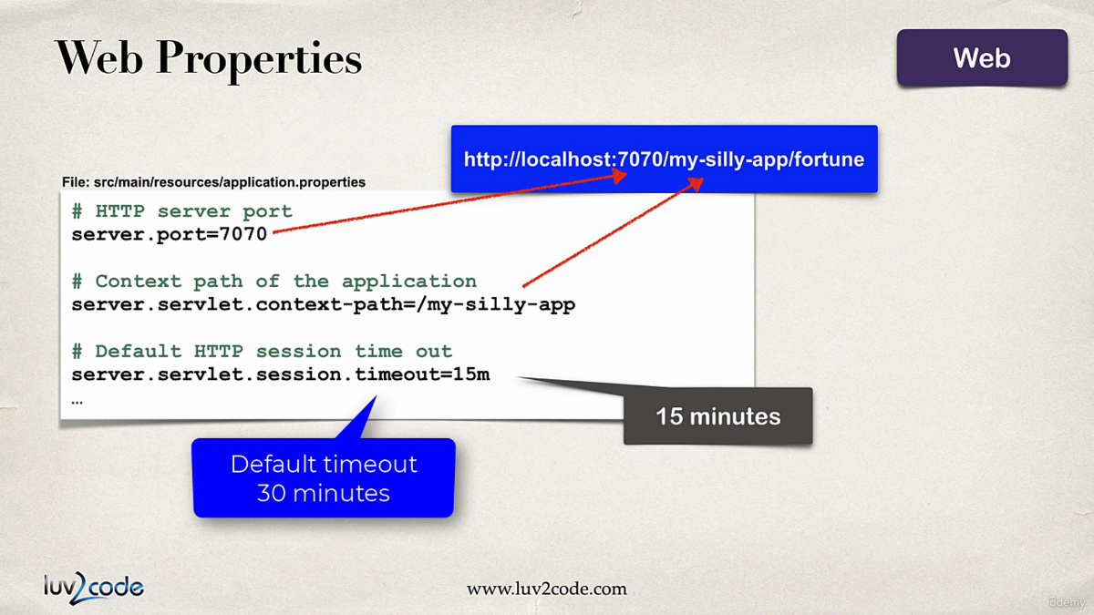

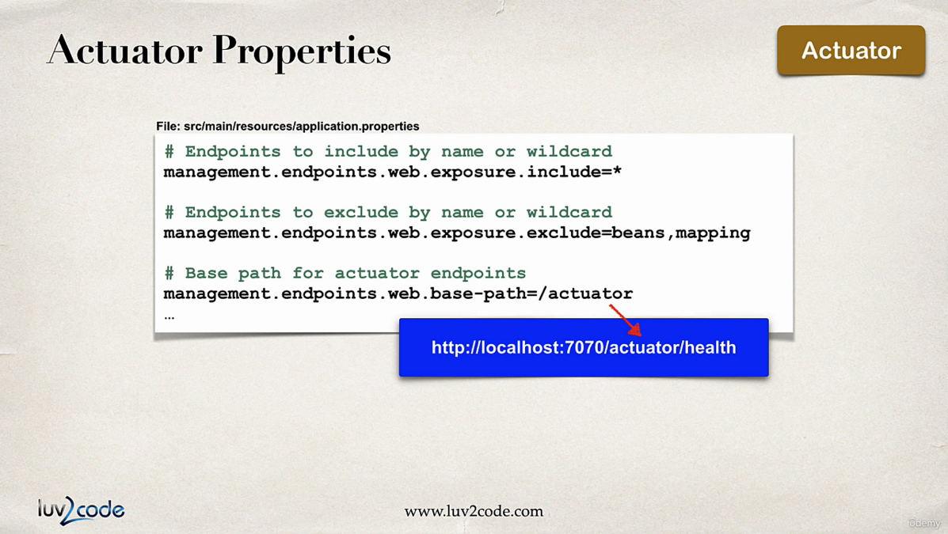

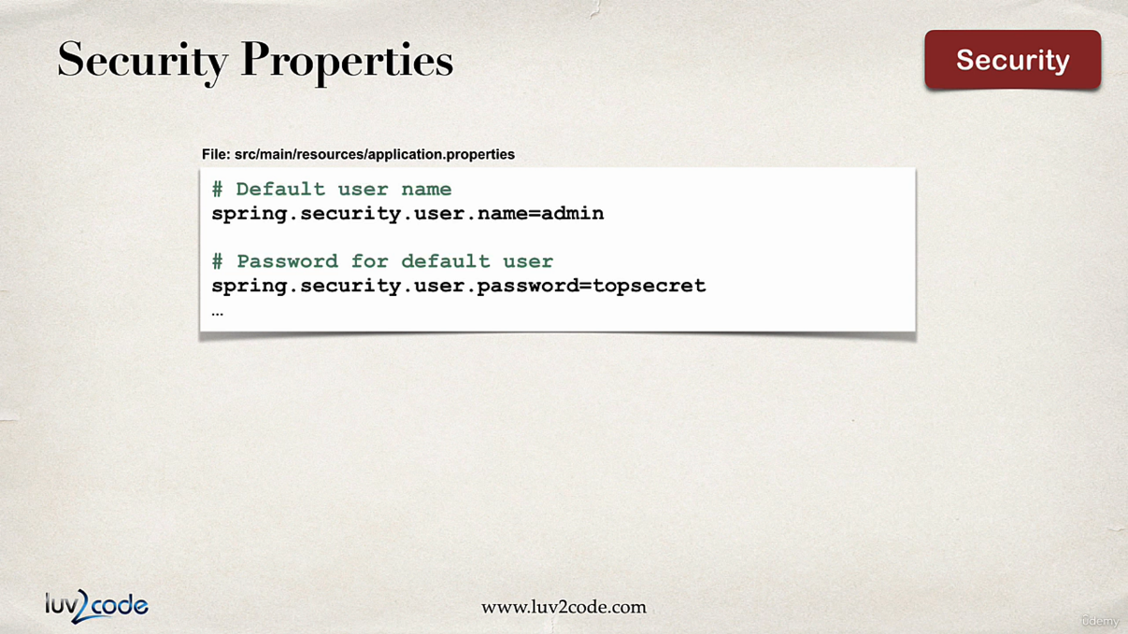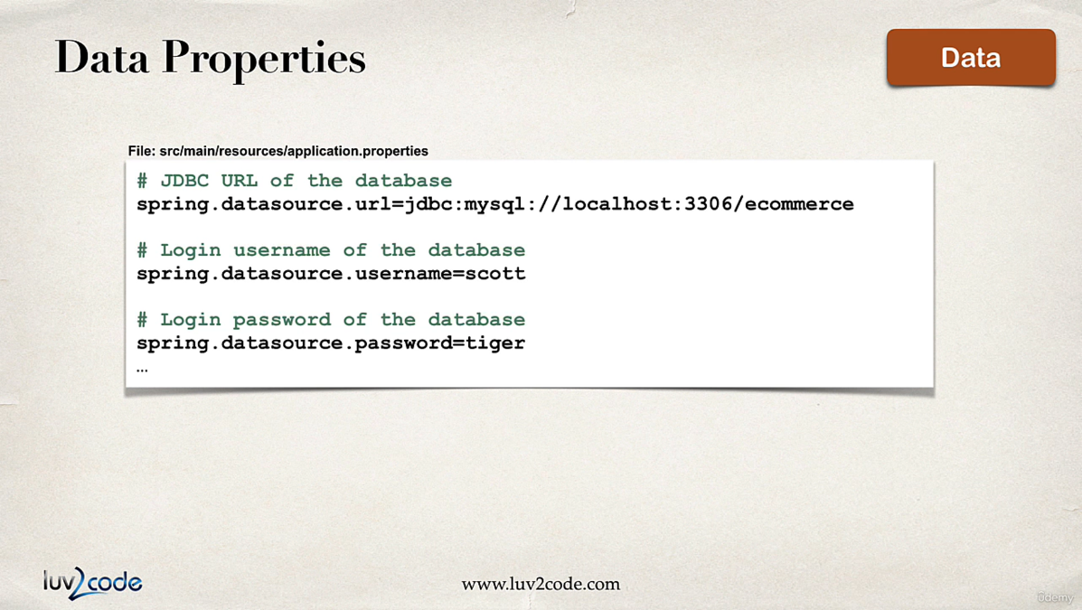

[**List of common properties**](https://docs.spring.io/spring-boot/appendix/application-properties/index.html)

**Spring Core**

**Inversion of Control:** Traditionally in Java Applications we create the objects of the class and inside that class if we need any other class we need to create the object of that class, we use to do this using **new** keyword, so in this approach the creation and managing the object of dependencies was taken care by developer

For e.g.,

public class Vehicle {  
 private Engine engine;  
   
 public void startVehicle() {  
 engine = new Engine();  
 engine.startEngine();  
 }  
}

Here Vehicle class requires the object of Engine class to run, hence we created It using **new** keyword.

In this way the problem is if there are many classes it will be hectic for programmer to manage everything.

Hence, we use **Inversion of control**, where when we create a object of Vehicle class, it automatically creates/invokes the objects of it dependency classes i.e. Engine in this case

Control is now with spring instead of programmer, so we call **Inversion of Control.**

**Dependency Injection:**

Injecting the object into the class or interface which are dependent on that is called dependency injection

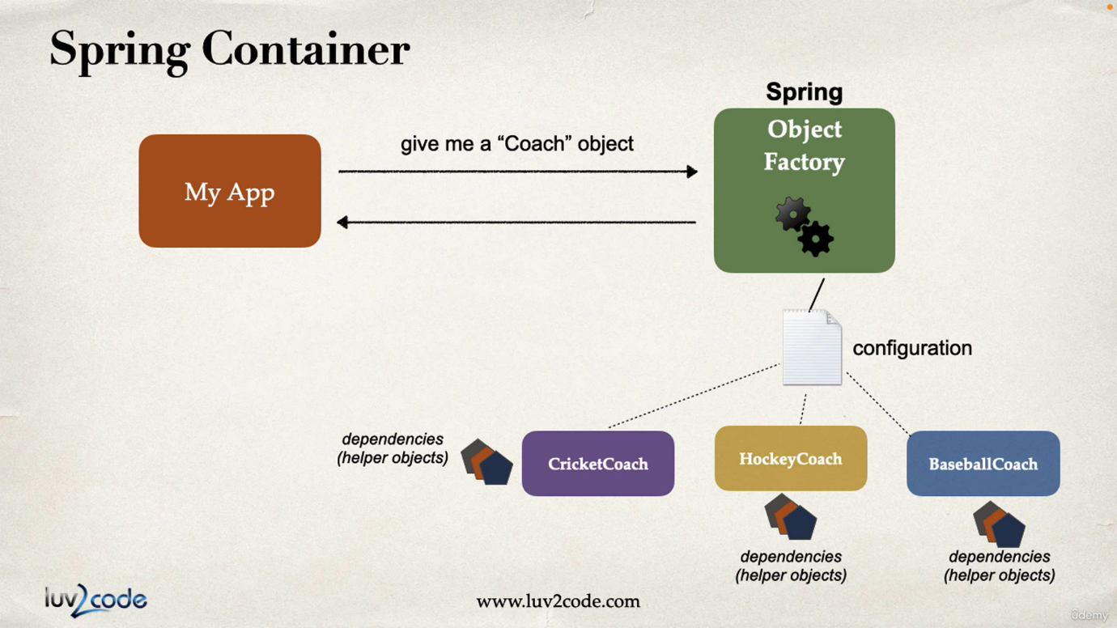

There are 3 types of Dependency Injection:

* Field injection
* Constructor injection (Recommended by Spring.io)
* Setter injection

**Autowiring:** When we Autowire a dependency class inside dependent class/interface, it automatically invokes the object of dependency class for the use of dependent class/interface. This can be done using **@Autowire** annotation

**Field injection**

Autowiring the dependency class at the declaration of that field.

**Constructor injection**

Autowiring the dependency class at the constructor.

**Setter injection**

Autowiring the dependency class at the setter method of that field.

**@Component –** This annotation marks the class as spring bean, bean is a java class that is managed by Spring. And this annotation marks the bean available for Dependency Injection. We can give names to beans using **@Component(“name”)**

**Component scanning**

By Default @SpringApplication implements @ComponentScan annotation, this allows spring to scan through the package and sub packages of the main application class where @SpringApplication is added.

This will scan for the beans, required for Dependency injection.

If we have some beans outside of current package we can mention them in @SpringAppliction( scanBasePackages = {…packages})

In our example

@SpringBootApplication(  
 scanBasePackages = {  
 "com.spring.boot.course.spring_di", //have to mention this also!! or else it will not scan this package.  
 "component.scan.test"  
 }  
)  
public class HelloWorldApplication {  
  
 public static void main(String[] args) {  
 SpringApplication.*run*(HelloWorldApplication.class, args);  
 }  
  
}

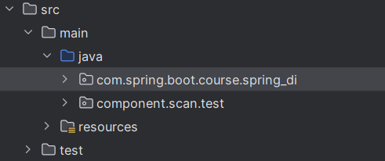

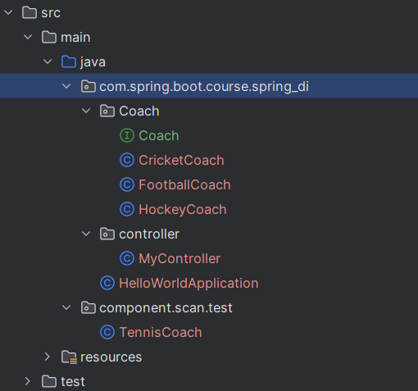

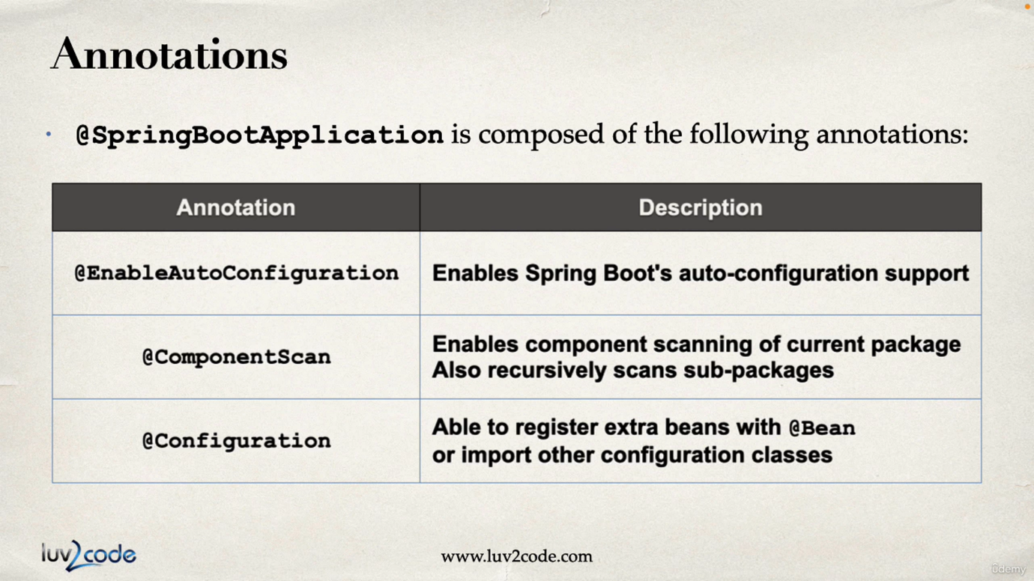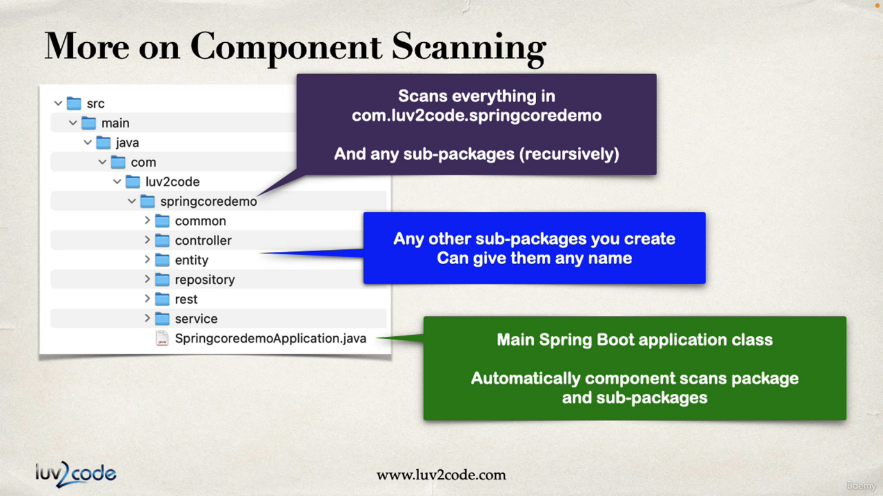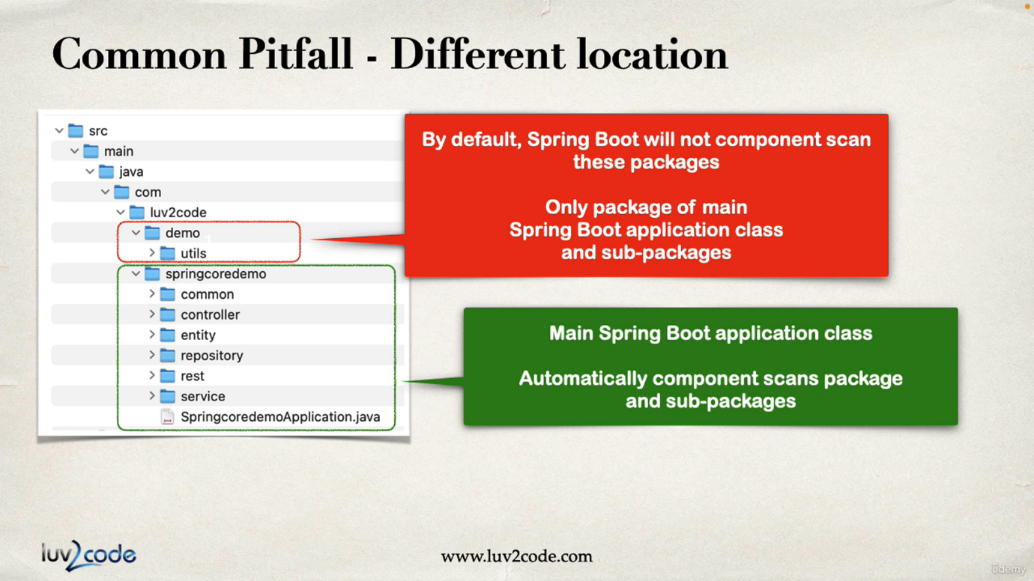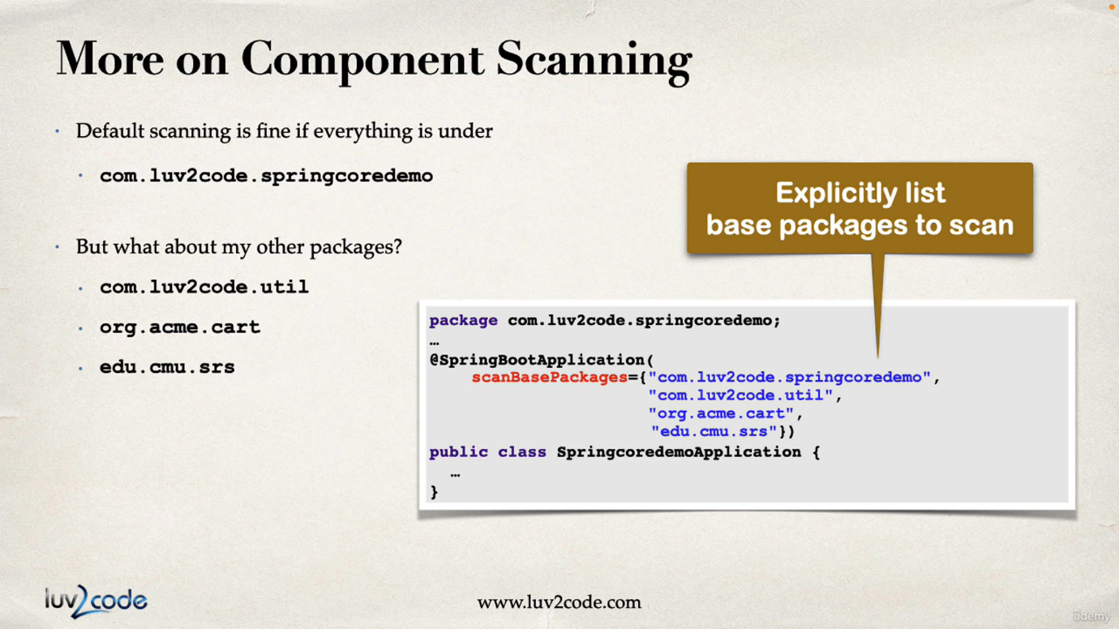

**Types of Dependency Injection**

1. **Field Injection –** We can perform Field injection by adding @Autowired above the declared field, where we are injecting the dependency

**Not recommended by spring.io**

Because it makes code harder to unit test

**Spring.io recommends constructor injection at first place or else setter injection**

@Autowired  
private Coach coach;

Coach here is an Interface so spring will find the classes that are implementing this interface and are beans(@Component), and inject the instance of that class into coach.

1. **Constructor Injection** – We can perform Constructor Injection by adding @Autowired above the constructor that sets the field.

**This is recommended by spring.io**

@Autowired //This is optional if we have only one constructor  
MyController(Coach coach) {  
 this.coach = coach;  
}

Spring behind the scenes performs this

*Coach coach = new CricketCoach();*

*MyController mycontroller = new MyController(coach);*

1. **Setter Injection** – We can perform setter injection by adding @Autowired above the setter of the field to which we are injecting.

We can call setter injection on any method not only on the setter. Just that the field should be set in that method along with dependency object as param to that function.

@Autowired  
public void setCoach(Coach coach) {  
 this.coach = coach;  
}

Spring behind the scenes performs this

*Coach coach = new TennisCoach();*

*MyController controller = new MyController();*

*controller.setCoach(coach);*

**@Qualifier** – This annotation is used to inject the specific bean.

When we are injecting a bean into an interface at that time there can be many beans that are implementing that interface so in this case there will be an ambiguity error hence, we can give the name of bean to inject that bean using Qualifier.

@Autowired  
MyController(@Qualifier("hockeyCoach") Coach coach, @Qualifier("cricket") Coach cricketCoach) {  
 this.coach = coach;  
 this.cricketCoach = cricketCoach;  
}

Here we are injecting coach with HockeyCoach class hence we have used “hockeyCoach” string. i.e. we should use same Class name as string with first letter smallcase. **CricketCoach -> “cricketCoach”, TennisCoach -> “tennisCoach”**

And we are injecting cricketCoach with CricketCoach class, but we have used “cricket” because in CricketCoach class we have given the name for bean using

**@Component(“cricket”)** like this we can give custom names for beans. And we cannot give same name.

**@Primary** – This annotation is used to make a bean primary, which is implementing a interface. Because that interface can be implemented by number of other classes and while autowiring this class is injected by default.

@Component("tennis")  
@Primary  
public class TennisCoach implements Coach {  
 public String workout() {  
 return "Hey I am Tennis Coach!!";  
 }  
}

Here TennisCoach is made primary bean.

@Autowired //This is optional if we have only one constructor  
MyController(@Qualifier("hockeyCoach") Coach hockeyCoach, @Qualifier("cricket") Coach cricketCoach, Coach coach) {  
 this.hockeyCoach = hockeyCoach;  
 this.cricketCoach = cricketCoach;  
 this.coach = coach;  
}

Here coach is having no Qualifier, so spring will inject the class that is implementing Coach interface but there are many classes that are implementing Coach interface. But TennisCoach is primary bean, hence this will be injected.

*There cannot be multiple Primary beans implementing same interface, it is an error.*

*If there is a Qualifier, then the Qualifier is given priority. Primary is only used when there is ambiguity.* ***Qualifier has higher priority than Primary.***

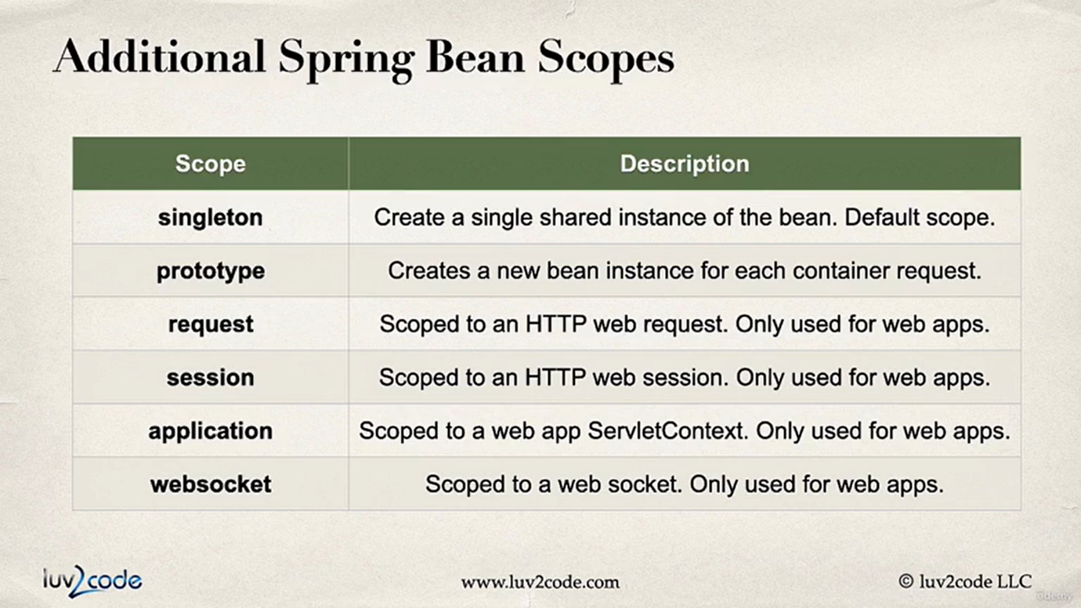

**Bean Lifecycle methods –**

We can define some methods which we can run on initialization or before destruction of a Bean.

**@PostConstruct –** Runs after constructor of a Bean.

**@PreDestroy –** Runs before the Bean is destroyed.

@PostConstruct  
public void postContruct() {  
 System.*out*.println("This is PostConstruct method of Life"); //This is called after constructor  
}  
@PreDestroy  
public void preDestroy() {  
 System.*out*.println("This is PreDestroy method of Life"); //This is called before the bean is destroyed  
}  
//NOTE: FOR PROTOTYPE SCOPE BEANS, SPRING DOES NOT DESTROY THE BEAN HENCE PreDestroy IS NOT CALLED.

**Java based Bean Configuration**

Instead of using annotations to mark a bean, we can do Bean configurations in two methods –

**1. XML based config** (Outdated)

**2. Java based config** (Recommended)

@Configuration  
public class CoachConfig {  
 @Bean  
 @Primary  
 public Coach cricketCoach() {  
 return new CricketCoach();  
 }  
  
 @Bean("football")  
 public Coach footballCoach() {  
 return new FootballCoach();  
 }  
}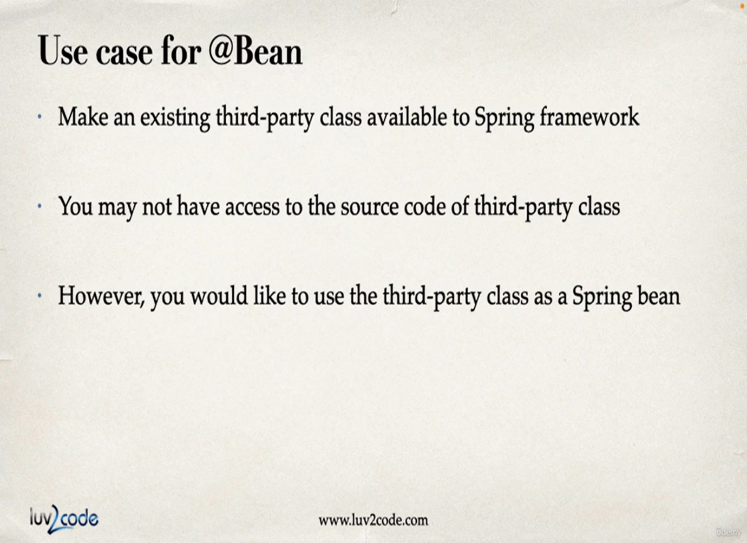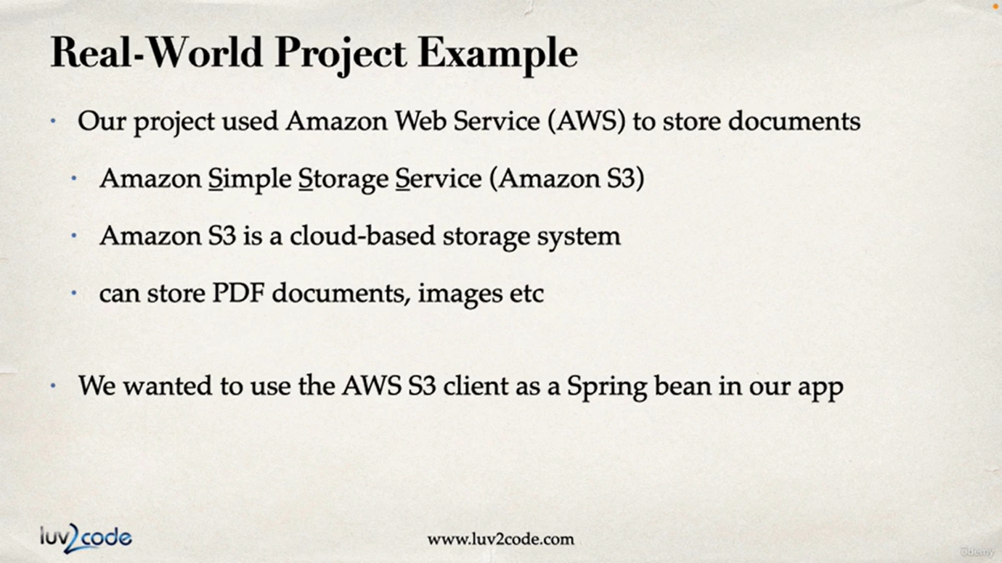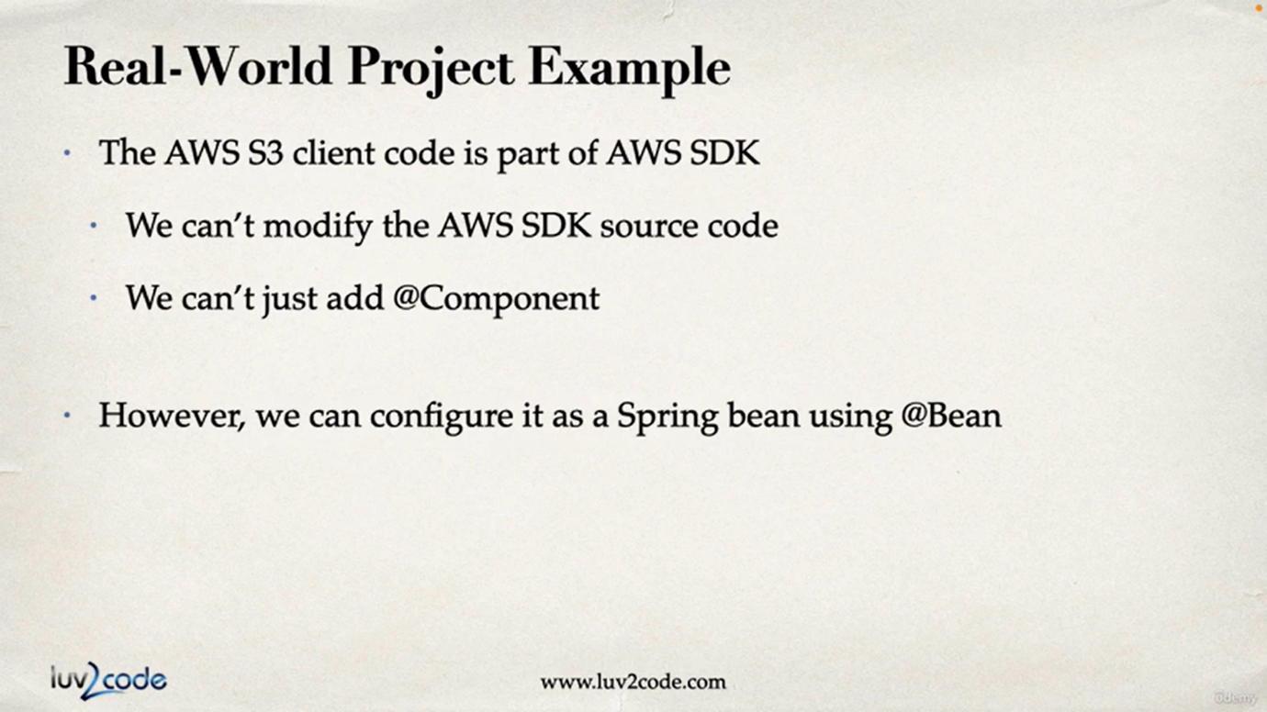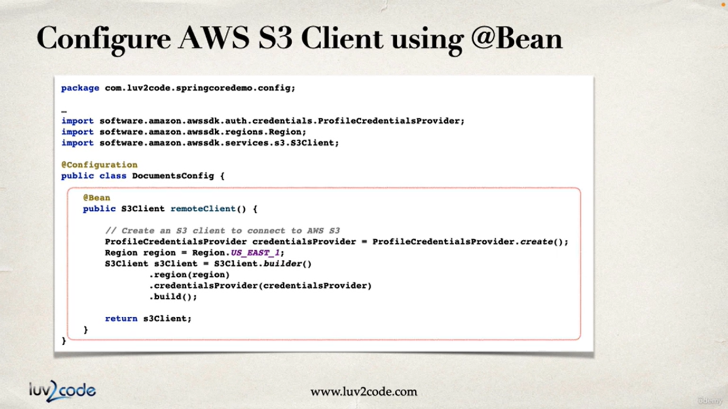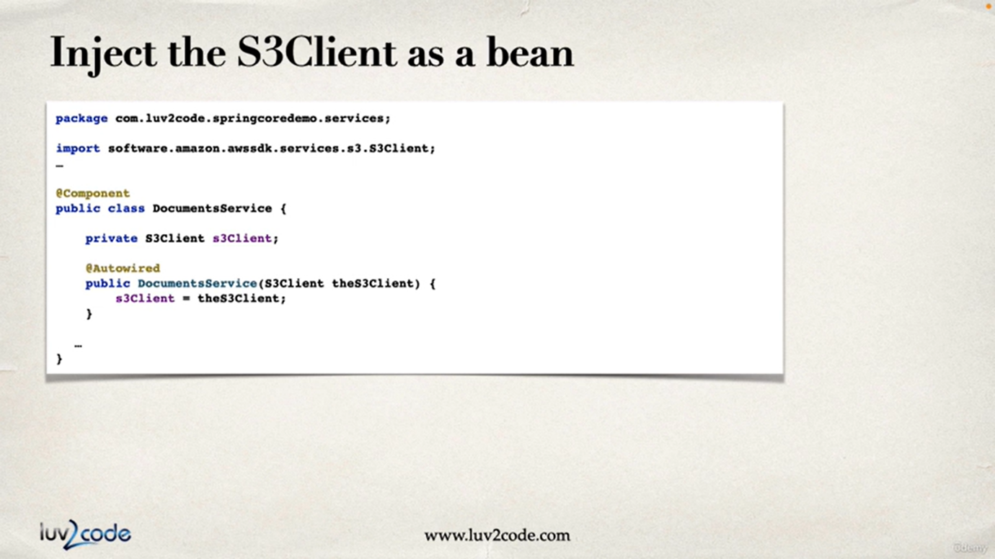

**ORM - Object-to-Relational Mapping**

Mapping a Java class to a Database table is called Object to Relational Mapping.

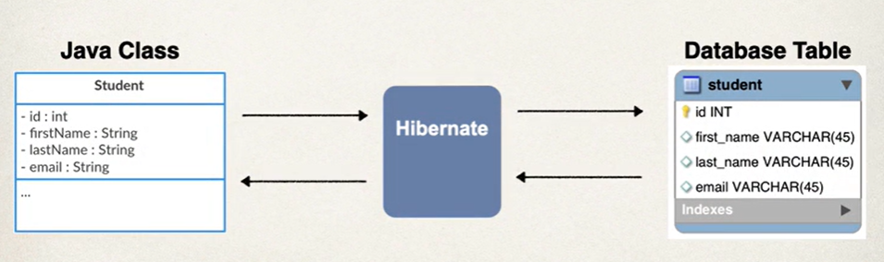

Here Java **Student class** is mapped with **student table** in Database using ORM tool, such as Hibernate which implements JPA specifications.

**JPA – Jakarta Persistence API**

JPA is a standard API for ORM

**JPA is specification**, not an actual implementation for providing ORM

JPA consists of **set of interfaces** that needs to be implemented so that we can do ORM.

There are 3rd party vendors which implements JPA, and that can be used in the application for ORM.

For e.g. **Hibernate** and **EclipseLink** are two JPA vendor implementations.

Benefits of using JPA specification to build an application is we do not need to be dependent of 3rd party vendor support. We can change the current vendor implementation with any other JPA vendor implementation. Because both will be implementing same interfaces of JPA which we have used in the app.

For e.g. If we are currently using EclipseLink, and for any reason we need to change it to Hibernate, we can easily do it without changing any major code.

**Hibernate**

Hibernate is a third-party vendor implementation of JPA and is most popular one. Hibernate is a framework used to persist/save or retrieving java object to the database.

**Benefits of Hibernate:**

* Hibernate handles all the low-level SQL code.
* Minimizes the amount of JDBC code that we must write
* Hibernate provides Object-to-Relational Mapping (ORM)

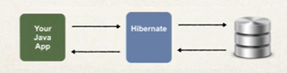

**Hibernate-JPA uses the JDBC for database communication.**

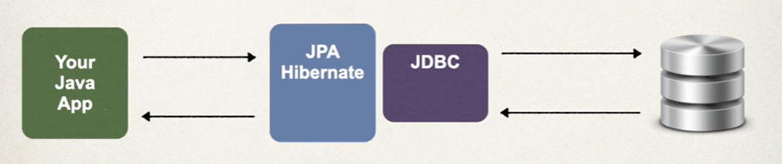

*JPA is a specification i.e. it contains the interfaces that need to be implemented. Hibernated implements these interfaces, by using JDBC to communicate with DB.*

**Spring Data JPA –** This dependency is required to create a JPA application.

**JDBC Driver to database of choice – MySQL Driver, PostgreSQL Driver etc. –** This dependency is required to connect the application with database.

In **application.properties** file we need to setup the database connection

*spring.datasource.url=jdbc:mysql://localhost:3306/student_tracker*

*spring.datasource.username=springstudent*

*spring.datasource.password=springstudent*

We need to give **Database URL, Username and Password** to start a connection.

**JPA Annotations**

**@Entity –** This marks a class that will be mapped to a table in the database

**@Table –** This gives the table name to which the class is mapped to. *(Optional if class and table name are same, in classname first letter is caps)*

**@Column –** This is used for the properties of class, and is used to map that property with column in the table *(Optional if we have same name for property and column)*

*It is recommended to use @Table and @Column.*

**Entity class –** Java class that is mapped to database table. It is annotated by **@Entity**

Entity class must have **public or protected No-arguments constructor**, with other constructors

* If there are no constructors declared Java will provide a default no arguments constructor by default.
* If we have declared some constructors, then we must declare a no arguments constructor also for Entity class.

**Primary key –** uniquely identifies the row in column, it must have unique values and cannot be empty/NULL. We can specify this in Java using **@Id**

**@Id –** annotation used to specify a primary key field.

**Auto-Increment** -In SQL we can Auto increment this field. i.e., when we add a new row the data for this column will be auto generated, by incrementing the value of last row.

And for this to work in Spring Boot we have a annotation called **@GeneratedValue**

**@GeneratedValue() –** Annotation used to specify that a value for that field is automatically generated by the strategy given.

**@GeneratedValue(strategy=GenerationType.IDENTITY) –** This will increment the value of last row by 1 and provide the value.

Some other GenerationType are – **AUTO, SEQUENCE, TABLE, UUID**

*We can also define our own custom Generation strategy by creating implementation of* ***org.hibernate.id.IdentifierGenerator*** *by overriding the method* ***public Serializable generate()***

@Entity  
@Table(name = "student")  
public class Student {  
 @Id  
 @GeneratedValue(strategy = GenerationType.*IDENTITY*)  
 @Column(name = "id")  
 private int id;  
  
 @Column(name = "first_name")  
 private String firstName;  
  
 @Column(name = "last_name")  
 private String lastName;  
  
 @Column(name = "email")  
 private String email;  
  
 //No args constructor  
 public Student() {}

Simple features that are to be built are **CRUD – C**reate, **R**ead, **U**pdate, **D**elete

**Data Access Object (DAO) -** This will be the helper class for communicating with Database

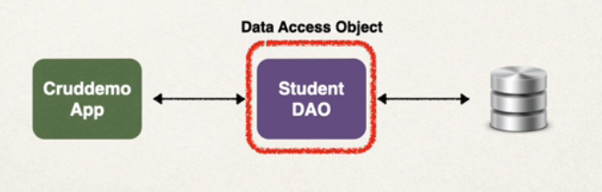

Some methods that will be implemented in DAO are

* save
* findById
* findAll
* findByColumnName *eg. findByFirstName, findByEmail etc*
* update
* delete
* deleteAll

DAO will need **JPA EntityManager** to perform these operations in Database

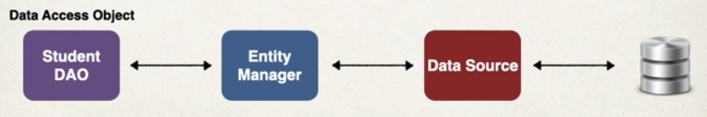

JPAEntityManagerwill require DataSource to execute database operations

**JPA EntityManager** and **DataSource** are setup automatically by spring using the DataSource connection info that we have provided in application.properties

spring.datasource.url=jdbc:mysql://localhost:3306/student_tracker  
spring.datasource.username=springstudent  
spring.datasource.password=springstudent

**JPA EntityManager and JPA Repository both can perform database operations**

**EntityManager –** Low level Database control, flexible, can create custom queries, low level of abstractions

**Repository –** High level of abstraction.

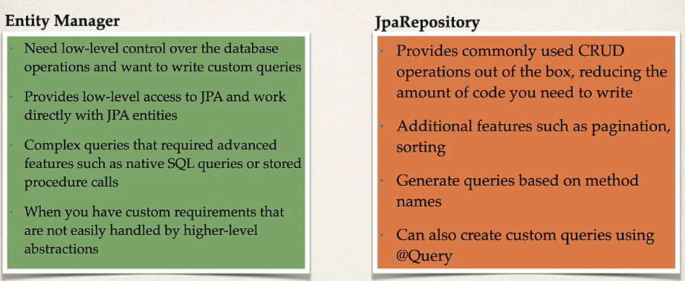

**C - Saving a Java object in database table**

Step 1: Create a **Student** Entity class, with table name and columns with primary key defined

Step 2: Create a **StudentDao** interface with save() method declared.

Step 3: Create a **StudentDaoImpl** class that implements the StudentDao interface.

Step 4: In **StudentDaoImpl** autowire **EntityManager** class, and entityManager object contains **persist()** method that is used to save Java object in database

Step 5: In save() method implementation take input parameter as Student object, and used **entityManager.persist(studentObj)** to save the object in database

Step 6: To execute this autowire the studentDao wherever required, and use the studentDao.save() method by passing Student Object.

**StudenDao interface**

public interface StudentDao {  
 public void save(Student student);  
}

**StudentDaoImpl class**

@Repository  
public class StudentDaoImpl implements StudentDao {  
  
 @Autowired  
 private EntityManager entityManager;  
  
 @Transactional  
 public void save(Student student) {  
 entityManager.persist(student);  
 }  
}

**@Repository –** This annotation is similar to/ sub annotation of @Component, this will make this class available for injection/autowiring. And will support JDBC exceptions. Have to add this one for DAO implementations where JPA is used.

**persist() –** this method is used to save the given object in the corresponding table of the database.

**@Transactional –** This annotation is used to manage the current transaction, by using this annotation spring will manage the transaction for us. Begin a transaction, persist the object and then commit the transaction. THIS IS REQUIRED WHERE WE ARE MODIFYING THE DB – insert/delete/update

If we want to start the auto increment from a specified number, we can do that by giving a value at creation of table / altering table

**AUTO_INCREMENT = 2000**

This will start the auto increment by 2000.

**R - Finding Data in database table and returning Java Obj**

**\* Finding single row using Id**

Step 1: Declare a new method **findById(int id)** in StudentDao interface.

Step 2: Implement the **findById(int id)** method in StudentDaoImpl class.

Step 3: In **findById(int id)** we will use **entityManager.find()** which will take two parameters, **first param is Entity class** of which table we are fetching the data from, and **second param is id** or the field which is primary key.

Step 4: **entityManager.find()** returns the Student object if found, or else will return **null**.

**StudentDao** interface

public interface StudentDao {  
 public void save(Student student);  
 public Student findById(int id);  
}

**StudentDaoImpl** class

public Student findById(int id) {  
 return entityManager.find(Student.class, id);  
}

**\* Finding multiple rows**

Step 1: Declare a **findAllStudents()** method in **StudentDao** interface

Step 2: Implement the method in **StudentDaoImpl** class

Step 3: for implementation we do not have a direct method in entitiyManager, hence we have to create our own query using **entityManager.createQuery(“JPQL query”, EntityClass)** which will take two parameters, **first is JPQL query**, and **second is EntityClass** and this will return an object of **TypedQuery<EntityClass>** with EntityClass type.

Step 4: Then use the created query object and call **getResultList()** method on that

**JPQL Queries** are similar to SQL, instead of using Table names we use Entity Classnames, instead of column names we use field name in the entity class.

**SQL –** SELECT * FROM student; **JPQL –** SELECT s FROM Student s; Here instead of **student** (table name) we use **Student** (Entity classname)

**SQL –** SELECT * FROM student WHERE id > 2; **JPQL –** SELECT s FROM Student s WHERE id > 2; Here **s** is just an alias for Student

**SQL –** SELECT * FROM student WHERE first_name LIKE ‘%hv%’; **JPQL –** SELECT s FROM Student s WHERE firstName LIKE “%hv%”; Here instead of **first_name** (column name) we use **firstName** (field name)

**StudentDao** interface

public List<Student> findAllStudents();  
public List<Student> findStudentsWithIdGreaterThan(int id);

**StudentDaoImpl** class

public List<Student> findAllStudents() {  
 TypedQuery<Student> query = entityManager.createQuery("SELECT s FROM Student s", Student.class);  
 return query.getResultList();  
}  
  
public List<Student> findStudentsWithIdGreaterThan(int id) {  
 TypedQuery<Student> query = entityManager.createQuery("SELECT s FROM Student s WHERE s.id > :givenId", Student.class);  
 query.setParameter("givenId", id);  
 return query.getResultList();  
}

Here **:givenId** is a **JPQL Named Parameter** which we can dynamically set using **query.setParameter(“paramName”, value)** where first param is paramName used in query and second param is value.

Syntax for named parameter - **:paramName**

**U – Updating the Data in database table**

**\*Updating single object/single row**

Step 1: Add a new method **updateStudentById(Student student)** in **StudentDao** interface

Step 2: Implement the added method in **StudentDaoImpl** class

Step 3: In implementation we have called **entityManager.merge (student)**, this will update the given student object with changes in the database table, we should not update the primary key field.

Step 4: Before calling this anywhere we need to find the Student object with given id, i.e. we can use our earlier implemented method **studentDao.findStudentById(int id)** by this we get the student object which need to be modified.

Step 5: update the fields of returned student object using the setters and pass it to the **updateStudentById(student)** method

**StudentDaoImpl** class

@Transactional  
public void updateStudentNameById(Student student) {  
 entityManager.merge(student);  
}

Here we need to use **@Transactional** as we are modifying the db table.

**Usage**

public void updateStudentNameById() {  
 int givenId = 1;  
 String change = "TestUpdate";  
 Student student = studentDao.findStudentById(givenId);  
 if(student != null) {  
 student.setFirstName(change);  
 studentDao.updateStudentNameById(student);  
 System.*out*.println("Student updated successfully with id = " + givenId);  
 System.*out*.println("UPDATED ROW");  
 System.*out*.println(studentDao.findStudentById(givenId).toString());  
 } else {  
 System.*out*.println("Found no student to update with id = " + givenId);  
 }  
}

Here we are first finding the object by id which is to be updated, and then update the fields of that object and pass it to the merger() method, which will updated that object.

**\*Updating multiple objects / rows**

For updating multiple objects based on the condition we need to use **createQuery()** method in which we pass the **JPQL query**  for update, and then call **executeUpdate()** method which will return the number of rows affected after the update.

**StudentDaoImpl** class

@Transactional  
public int updateStudentsLastNameByMailType(String mailType, String changedName) {  
 return entityManager.createQuery("UPDATE Student SET lastName = 'TestBulkUpdate' WHERE email LIKE '%@gmail.com'").executeUpdate();  
}

**Usage**

public void updateStudentsNameByMailType() {  
 String givenName = "TestBulkUpdate";  
 String mailType = "@gmail.com";  
 int rowsAffected = studentDao.updateStudentsLastNameByMailType(mailType, givenName);  
 System.*out*.println("BULK UPDATE");  
 if(rowsAffected > 0) {  
 System.*out*.println(rowsAffected + " Students updated successfully");  
 } else {  
 System.*out*.println("No students updated");  
 }  
}

**D – Deleting the Data in database table**

**\*Deleting an object/row by primary key**

Step 1: Add a new method **deleteStudentById(int id)** in **StudentDao** interface

Step 2: Implement the added method in **StudentDaoImpl** class

Step 3: In implementation we have called **entityManager.remove(student)**, this will delete the given student object.

Step 4: Before this we need to find the student object with given id, i.e. we can use **entityManager.find(Student.class, id)** by this we get the student object which need to be deleted. THIS WE HAVE TO IMPLEMENT INSIDE THE METHOD WHERE WE ARE CALLING remove(student) METHOD. HAS TO BE PART OF SAME TRANSACTION

**StudentDaoImpl** class

@Transactional  
public int deleteStudentById(int id) {  
 Student student = entityManager.find(Student.class, id);  
 //We need to fetch the object required to delete inside this method because if we fetch it outside,  
 // entity manager will be managing that object and we cannot delete that.  
 if(student != null) {  
 entityManager.remove(student);  
 return 1;  
 } else return 0;  
}

**Usage**

public void deleteStudentById() {  
 int givenId = 1;  
 int deletedRows = studentDao.deleteStudentById(givenId);  
 if(deletedRows == 1) {  
 System.*out*.println("Student is deleted successfully with id = " + givenId);  
 } else {  
 System.*out*.println("Found no student to delete with id = " + givenId);  
 }  
}

**\*Deleting multiple objects / rows**

For deleting multiple objects based on the condition we need to use **createQuery()** method in which we pass the **JPQL query** for delete, and then call **executeUpdate()** method which will return the number of rows affected after the delete.

**StudentDaoImpl** class

@Transactional  
public int deleteStudentsByMailType(String mailType) {  
 String query = "DELETE FROM Student WHERE email NOT LIKE '%"+mailType+"'";  
 return entityManager.createQuery(query).executeUpdate();  
}

**Usage**

public void deleteStudentsByMailType() {  
 String mailType = "@gmail.com";  
 int rowsAffected = studentDao.deleteStudentsByMailType(mailType);  
 System.*out*.println("BULK DELETE");  
 if(rowsAffected > 0) {  
 System.*out*.println(rowsAffected + " Students deleted successfully");  
 } else {  
 System.*out*.println("No students deleted");  
 }  
}